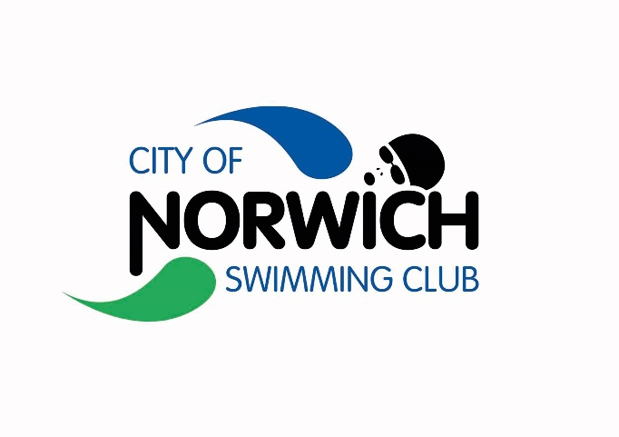

City of Norwich Swimming Club

2023 Distance Meet

Held under Swim England Regulations, Technical Rules of Swimming and to the Swim England Open Meet Licensing Criteria

Friday 15th September 2023, Start 17:10, License L3 Number: 3ER23TBC
Friday 22nd September 2023, Start 17:10, License L3 Number 3ER23TBC

Entrants must be Club Compete Swim England Members

This is a level 3 licensed time trial to give opportunity to swimmers wishing to achieve a time in the 800m and 1500m freestyle with the potential to qualify for the Norfolk County Championships and Swim England Regional SC Championships.

Sportspark UEA

Event Information and Entry Form

CoNSC Meet Promoter: Tracey Spinner

City of Norwich Swimming Club Distance Meet 2023
(Level 3 License No. 3ER23TBC and 3ER23TBC)
Sportspark ,UEA, Norwich: Fri 15th & Fri 22nd September 2023

- The competition is a Level 3 licensed meet, held under Swim England Regulations, Technical Rules of Swimming., and Swim England Licensed Meet criteria and these conditions.
- The competition is only open to members of Clubs Affiliated to Swim England East Region. Competitors must be Club Compete members of an affiliated club, eligible to compete.
- Entries will only be accepted from competitors registered as members of Swim England, SASA or WASA or competitors from a country affiliated to FINA, and priority will be given to SE East Region Clubs.
- The promoter is Tracey Spinner on behalf of City of Norwich Swimming Club.
- Cost of entry will be £7 per event for external clubs. CONSC swimmers - included as part of the CONSC Club Champs Bundle.
- Age-groups: Age 11, 12, 13, 14, and 15 and over.
- Age as at 31st December 2023.
- Events: All events will be timed finals.
- Short course or converted long course times will be accepted. Swimmers with no existing time are asked to provide coach approved times that meet the entry criteria.
- The competition will take place at the Sportspark, UEA, in an 8 Lane Short Course (25m) Racing Pool with anti-wave devices in place.
- There will be electronic timing & 8-lane display. A secondary strobe for the starting system is available.
- Heats will be swum as mixed age and gender with swimmers seeded by entry times. Over the top starts may be used at the referee’s discretion.
- City of Norwich SC Swimmers to enter using SCM. Payment will also be via SCM and triggered immediately after the closing date.
- For Club Entries, Hytek entry file is the preferred method of entry, email to: tbirdspinner@gmail.com.
- The Meet closing date is 12:00 Midday on Monday 28th August 2023.
- Accepted and rejected entries will be posted on the club website within 1 week of the closing date. No individual notification will be made. The meet will remain open to reserves until 15th September 2023.
- External clubs should make payment by BACS to CONSC Acct: 00919204, Sort 30-96-17. Ref DM23 XXXX (with XXXX being the club short code or the first 4 letters of swimmer’s surname).
- Events are limited to 7 heats of each event, on a first come first served basis. In the event of oversubscription, priority will be given to those swimmers submitted by the final club with the faster submitted time, taking the age groups into consideration.
- Withdrawals must be advised using swim-meet link at least 2 hours before the gala starts.
- Results will be posted live to Meet Mobile; after the event they will be posted on the CoNSC website & sent to the British Swimming for inclusion in national rankings.
- There will be no charge for spectators, and no programmes. Hytek heat sheets will be available to those on Meet Mobile.
- Participants and spectators are asked to note that during all 25m galas the Sportspark photography policy will be in operation; mobile phone use is not permitted within changing areas, toilets, showers or poolside. Photography and filming will not be permitted in any of these areas or on the spectator gallery, at any time. Please understand that this is the policy and do not create conflict by challenging our volunteers. Just leave your phones and ipads at home.
- All participants must observe the safety precautions in operation at the Sportspark, UEA. Neither the Promoter nor City of Norwich Swimming Club will be responsible for any loss or damage occurring during this meet.
- The Data Protection Act 2018 requires us to provide you with certain information and to obtain your consent before processing data about you. Processing includes: obtaining, recording, holding, disclosing, destruction or retaining information. We require certain personal data for the purposes of making entries to the competition, managing the meet and the submission of results to Rankings. The information provided by you will be processed in accordance with the Data Protection Act 2018. Consent to process such personal data is deemed to have been given by the submission of the entry.
- Use the Swim-Meet link: https://www.swim-meet.com/Availability/?m=1357 to put forward your officials availability. Distance Meets are particularly hard to resource, so please put yourselves forwards if you are licensed.
- Any matter not covered by these conditions will be determined by the Promoter and Referee, subject to Swim England Regulations and Technical Rules of Racing and Swim England Licensed meet Criteria.

Qualifying Standards

Cut off times – swimmers must not be faster than these times.

800m Free | 11 | 12 | 13 | 14 | 15&o
Boys Cut-Off | 11:00.00 | 10:15.00 | 9:30.00 | 9:15.00 | 9:00.00
Girls Cut-Off | 10:45.00 | 10:30.00 | 9:45.00 | 9:30.00 | 9:15.00
1500m Free | 11 | 12 | 13 | 14 | 15&o
Boys Cut-Off | 21:45.00 | 20:15.00 | 19:15.00 | 18:15.00 | 17:15.00
Girls Cut-Off | 21:45.00 | 20:15.00 | 19:15.00 | 18:45.00 | 18:30.00

- Meet Schedule

Friday 15th September
Session 1 – Warmup 16:30, Race 17:10
101 | Mixed | 800m Freestyle

Friday 22nd September
Session 2– Warmup 16:30, Race 17:10
201 | Mixed | 1500m Freestyle

City of Norwich Swimming Club Distance Meet 2023
(Level 3 License No. 3ER230422 and 3ER230423)
Sportspark ,UEA, Norwich: Fri 15th and Fri 22nd September 2023

VISITING CLUB - INDIVIDUAL ENTRY FORM
FORENAME: |  | SURNAME:
CLUB: |  | AGE (@ 31/12/2023):
SEX: | MALE/FEMALE | DATE OF BIRTH:
EMAIL ADDRESS: |  | DISABILITY CLASSIFICATION:
TELEPHONE NO: |  | SE MEMBER NO
EVENT | COST PER EVENT |  | ENTRY TIME (SC) |  |  |  | IF CONVERTED STATE LONG COURSE TIME:
800 FREESTYLE | £7.00
1500 FREESTYLE | £7.00
 | Total Events |  |  |  |  |  | £
 |  |  | Total: |  |  |  | £

CLOSING DATE FOR ENTRIES IS 12:00 Midday on Monday 28th August 2023

Officials should register their availability online using Swim-Meet:
https://www.swim-meet.com/Availability/?m=1357

