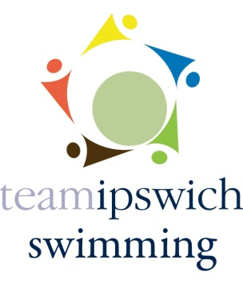

Egg-citing Easter Novice 2022

Event Information

Teamipswich are looking forward to welcoming you to our Egg-citing Easter Novice. This meet for some will be their first experience of a swimming competition. We hope to make it a fun day!

Spectators
- We are really pleased to be able to welcome spectators back to Crown Pools
- Doors will open at 2pm

Entrance & Exit
- Entrance – please follow the signs (see map attached) for swimmer and spectator entrance
- Exit – is via the fire escape doors facing the grass area

Withdrawals
- Please can all withdrawals be made by 6pm on Friday
- Please notify withdrawals to your club/coach who will then notify us
- Subsequent withdrawals must be verbally notified on the day to the Promoter for the relevant event to avoid holding up the competition whilst we look for “missing” swimmers. Heats will be swum with empty lanes.
Masks
- Crown pools have no requirements for mask wearing but please be understanding that some people may still feel they wish to wear one

Covid 19
- Although restrictions have now been lifted, could we please ask if anyone is feeling unwell or has a high temperature to please stay home

Session times

Saturday

Warm Up: 2:30 pm
Start: 3:00 pm
Est. Finish: 5:40 pm

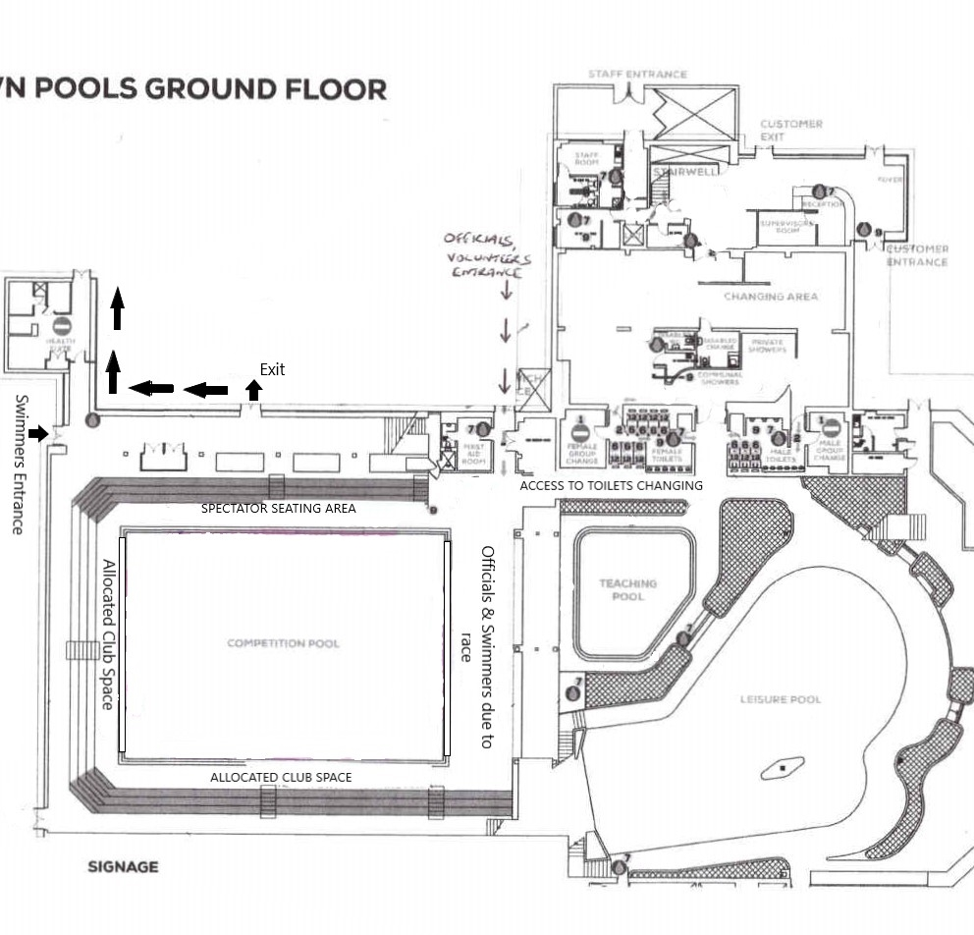
Crown Pools Map

