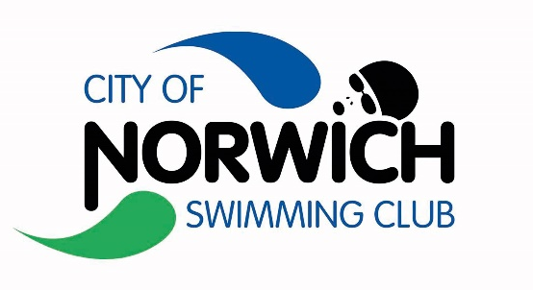

City of Norwich Swimming Club

2021 Club Championships

100IM Time Trials

Held under Swim England Laws & Regulations, the Swim England Technical Rules of Swimming and to the Swim England Open Meet Licensing Criteria

Sat 25th September 2021 - License L3 Number: 3ER21TBC

For City of Norwich Swimming Club Members Only

Entrants must be CAT 2 Swim England Members

Sat 25th Sep Start TBC – After S4 of Main Club Champs Events
Sportspark UEA

Event Information and Entry Form

CoNSC Meet Promoter: Tracey Spinner

City of Norwich Swimming Club Championships 2021
100IM Time Trials (Level 3 License No. XXXXXXXX)
Sportspark ,UEA, Norwich: Sat 25th September 2020

- The competition is a Level 3 licensed meet, held under Swim England Laws, Swim England Technical Rules of Swimming., and these conditions.
- The competition is only open to members of City of Norwich Swimming Club. Competitors must be Category 2 members of an affiliated club, eligible to compete and registered in accordance with Swim England Laws and Technical Rules, and may enter in the name of one club only. Entries will only be accepted from competitors registered as members of Swim England, SASA or WASA or competitors from a country affiliated to FINA.
- The promoter is Tracey Spinner on behalf of City of Norwich Swimming Club.
- Medals will be given on the day for each event to the first 3 places by age group. Trophies will be given on the day for trophy events in each age group.
- Age-groups: Age 9, 10, 11, 12/13, 14/15, 16yrs/over.
- Age as at 25th September 2021.
- Events: All events will be timed finals. 9yrs/+ may enter the 100m IM.
- Entries with No Time will be accepted. Short course or converted long course times will be accepted.
- Those swimmers in possession of a Swim England Certificate of Swimming Disability or those swimmers whose membership details record a disability Sport Class are welcome to enter the competition.
- Accepted and rejected entries will be posted on the club website within 2 weeks of the closing date. No individual notification will be made.
- The competition will take place at the Sportspark, UEA, in an 8 Lane Short Course (25m) Racing Pool with anti-wave devices in place. There will be electronic timing & 8-lane display
- Heats will be swum as mixed age with swimmers seeded by entry times.
- Over the top starts may be used at the referee’s discretion.
- All entries should be submitted using SCM. Cost of entry will be £4.00 per event; invoiced through SCM after the closing date. Closing date is Monday 6th September, 2021.
- Results will be posted live to Meet Mobile, after the event they will be posted on the CoNSC website & sent to the British Swimming for inclusion in the national rankings.
- In accordance with the Swim England Child Safeguarding Policies and Procedures, any parents or carers of swimmers under the age of 18 who wish to take photographic or video images are requested to focus on their own child as much as reasonably possible and to avoid including other children in those images. Should you have any concerns about photography or filming please bring them to the attention of the promoter.
- Participants and spectators are requested to follow the Swim England guidelines for photography and use of photographs on social media. The Swim England Child Safeguarding Policy and Procedures, Wavepower 2016-19 Section 2 provides guidance on the use of social networking (page 72-75) and guidance on photography (page 76–77). https://www.swimming.org/swimengland/wavepower-child-safeguarding-for-clubs/ . Both sets of guidance apply if social media platforms are being used to share images or recordings either after the meet or during live streaming of the event.
- No photography is permitted in changing rooms. Any person found to be contravening this condition will be required to leave the competition and venue without refund.
- All participants must observe the safety precautions in operation at the Sportspark, UEA. Neither the Promoter nor City of Norwich Swimming Club will be responsible for any loss or damage occurring during this meet.
- The Data Protection Act 2018 requires us to provide you with certain information and to obtain your consent before processing data about you. Processing includes: obtaining, recording, holding, disclosing, destruction or retaining information. We require certain personal data for the purposes of making entries to the competition, managing the meet and the submission of results to Rankings. The information provided by you will be processed in accordance with the Data Protection Act 2018. Consent to process such personal data is deemed to have been given by the submission of the entry.
- Any matter not covered by these conditions will be determined by the Promoter and Referee, subject to Swim England Laws, Regulations and Technical Rules of Racing.
- There will be no charge for spectators, and no programmes.

City of Norwich Swimming Club Championships 2021
100IM Time Trials (Level 3 License No. 3ER21TBC)
Sportspark ,UEA, Norwich: Sat 25th September 2021

Saturday 25th September
Session 1 – Warmup 12.00pm* , Start 12.30pm*
101 | Girls | 100 IM 9/over
102 | Boys | 100 IM 9/over

* Session start times may change depending on entries. Information will be posted with accepted entries. To start immediately after S4 of main Club Champs

